# C:\Users\harish\Downloads\clg logo.jpegGANDHI COLLEGE OF ATRS AND SCIENCE FOR WOMEN N.KANDAMPALAYAM

# A PROJECT REPORT SUBMITTED BY

**R.ROSHINI**

**S.SASIKALA**

**BACHOLAR OF SCIENCE PHYSICS**

**OCTOBER 2023**

# Define Problem/Problem understanding Specify the business Problem:

Highly priced products of iphone is one of the biggest challenges currently being faced by humanrace. Compatibility with other software and entry areas of higher compitition are the weaaknesses face some key challenges.

# Business requirements:

Apple products are as easy to use at work as they are in your everyday life

# Literature Survey:

A literature survey is a method of operating iphone would typically involve researching excisiting studies ,academic, and publication related to the topic

**EMPATHY MAP**

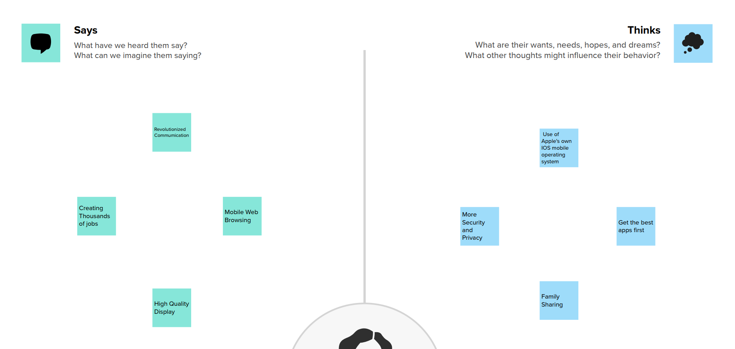

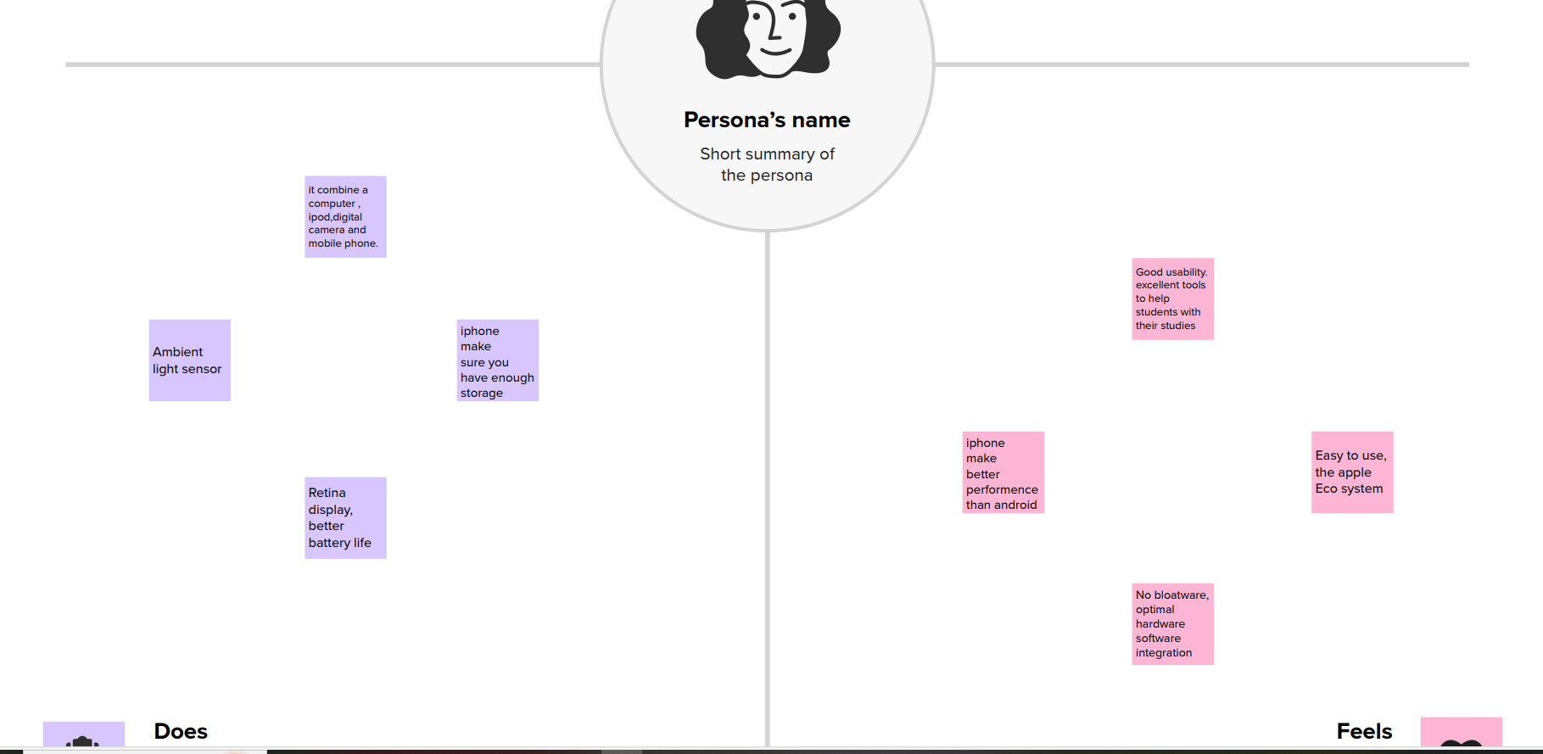

**BRAINSTROMING MAP**

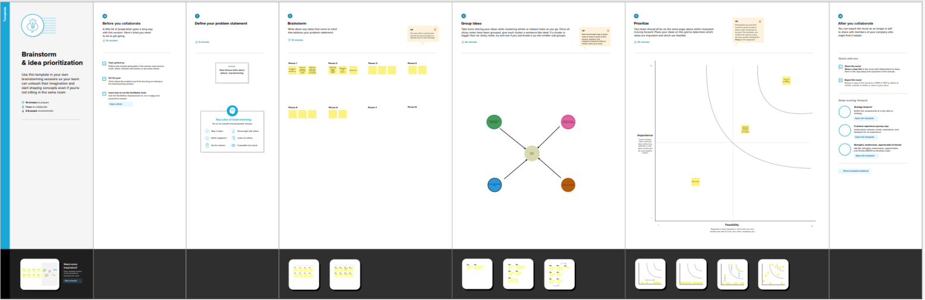

# Data collection & extraction?

Data contains all the meta information regarding columns described in the CSV files.

# Data preparation:

**Prepare the data for visualization**,

Basically this process helps to make the data easily understantable & ready for creating visualizations to gain in sights into the performance & efficiency.

# Data visualization:

Data Visualization is the process of creating graphical representations of data in order to help people understand and explore the information.

The goal of data visualization is to make complex data sets more accessible intuitive and easier

to interpret.

By using visual elements such as charts, graphs and maps, data visualizations can help people quickly identify Patterns, trends and outliers in the data.

# No. of unique visualizations

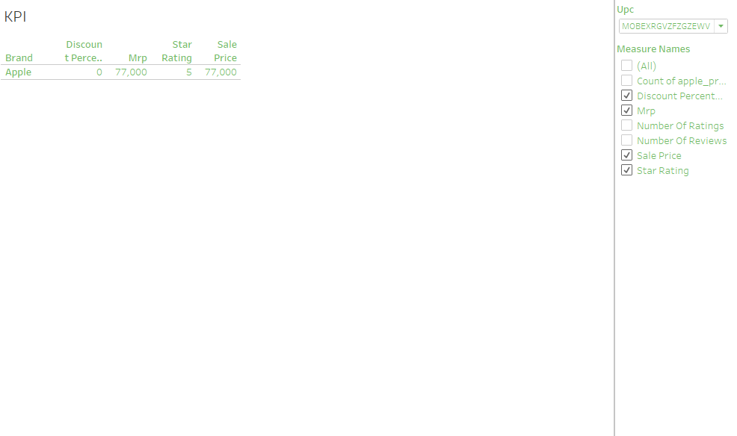

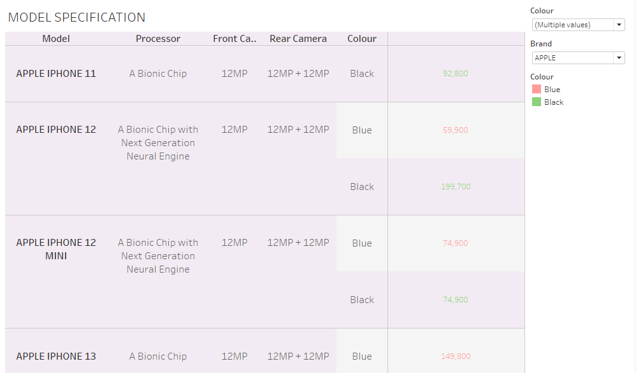

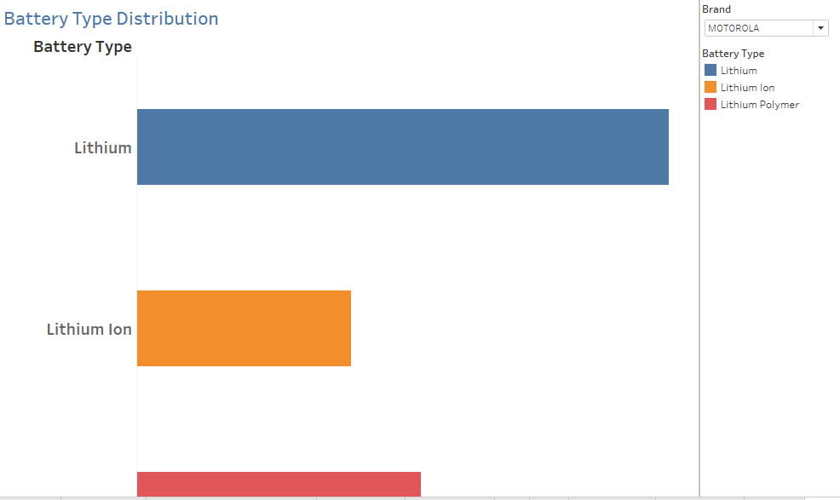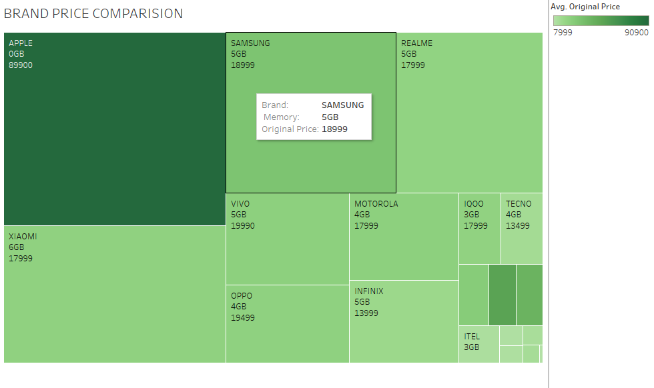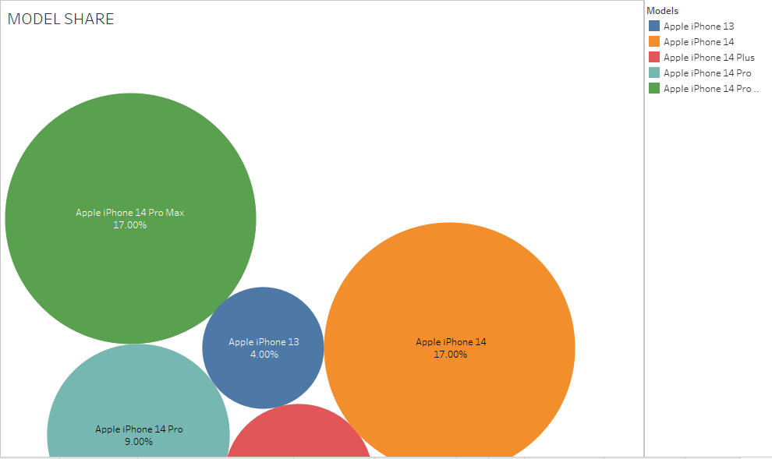

**Dashboard:**

A dashboard is a graphical user interface (GUI) that displays information & data in an organized, easy -to- read format.

Dash board can be used in a variety of setting, such as business, finance, manufacturing, health care and many other industries.

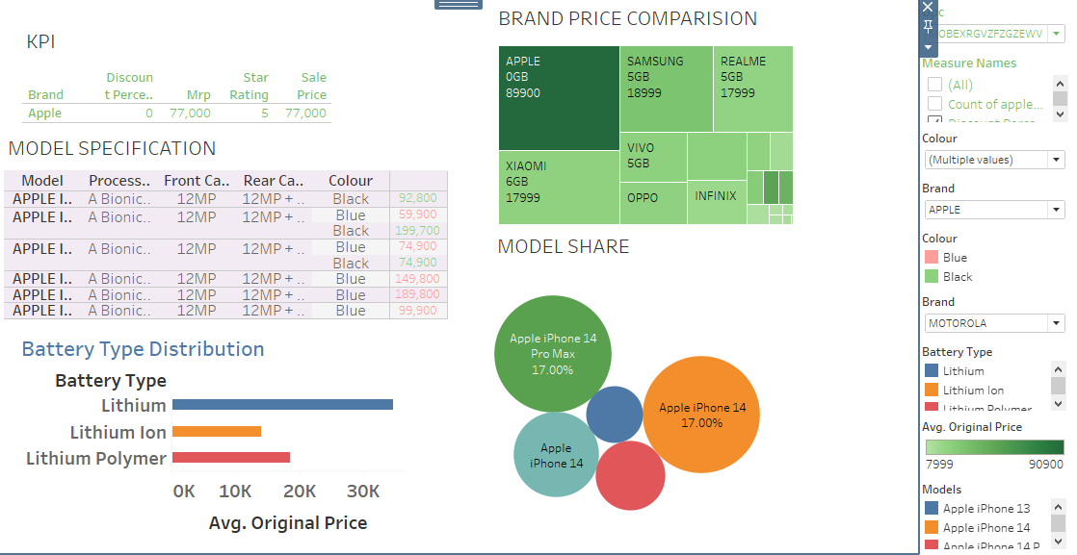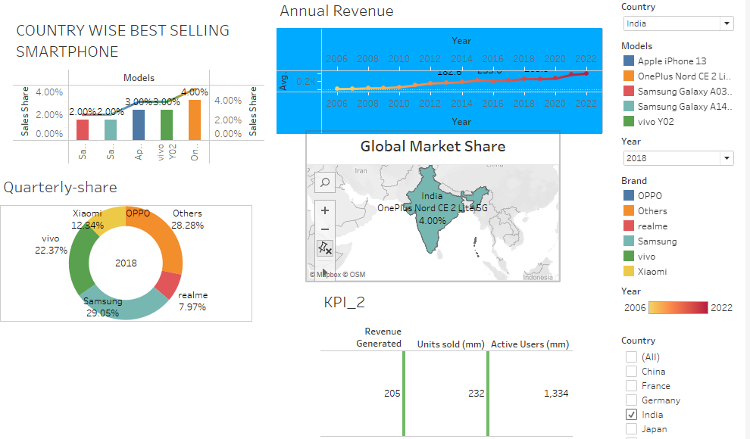

# Story:

A data story is a way of presenting data and analysis in a narrative format, with the goal of making the Information more engaging and easier to understand.

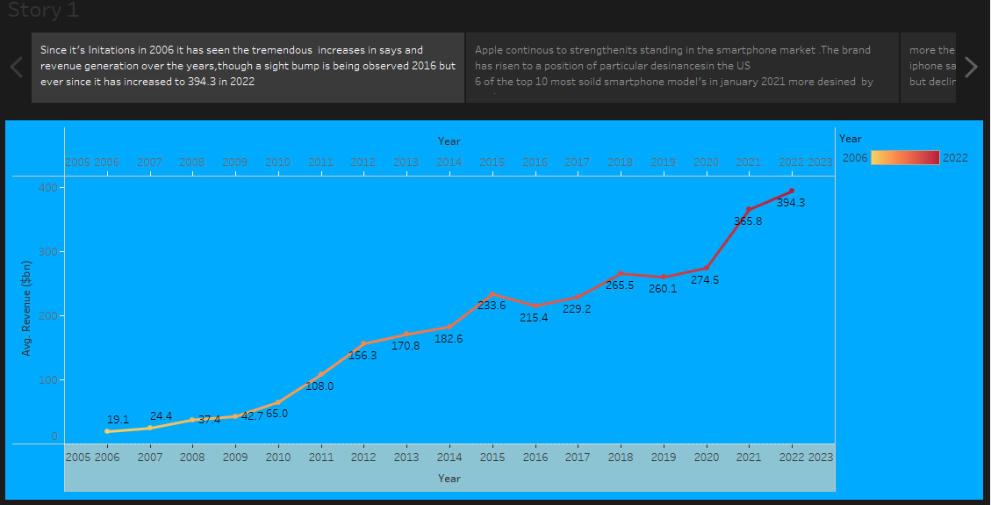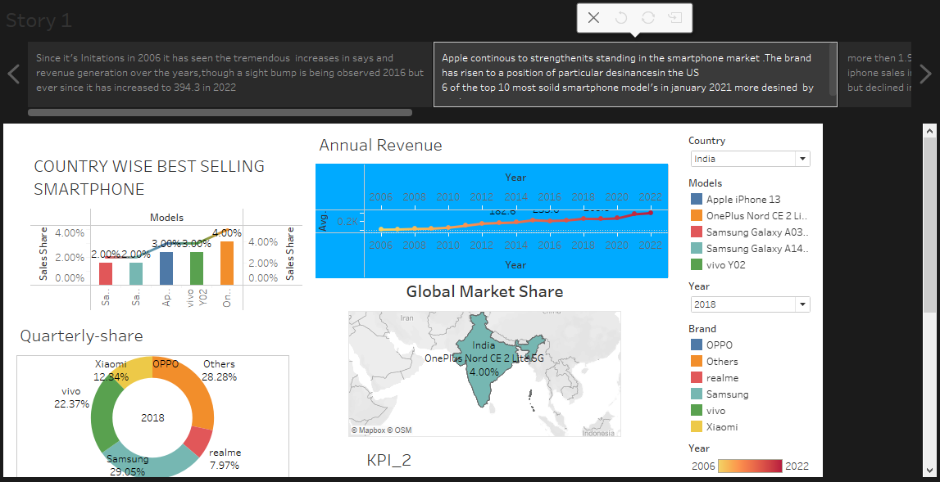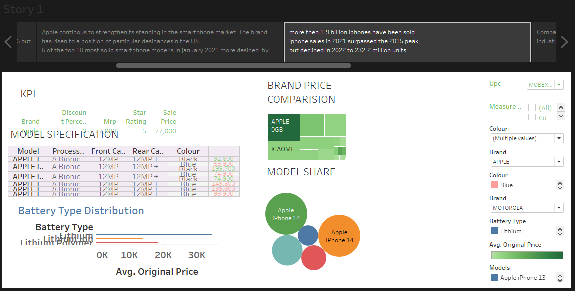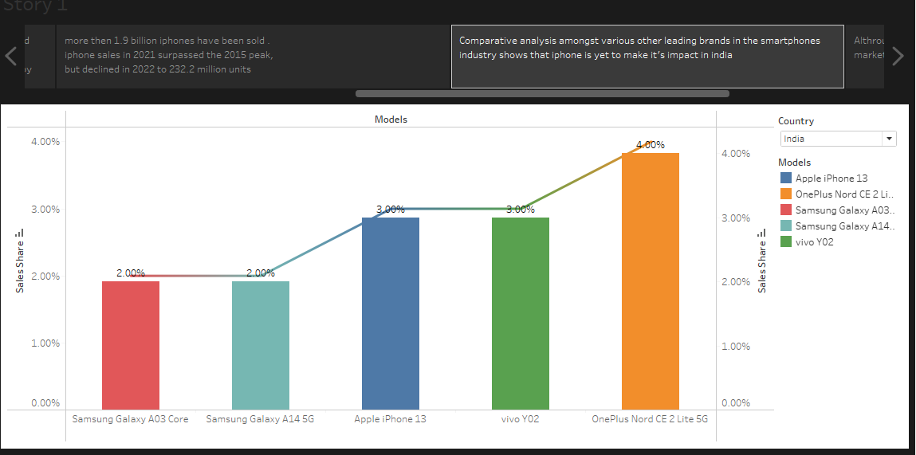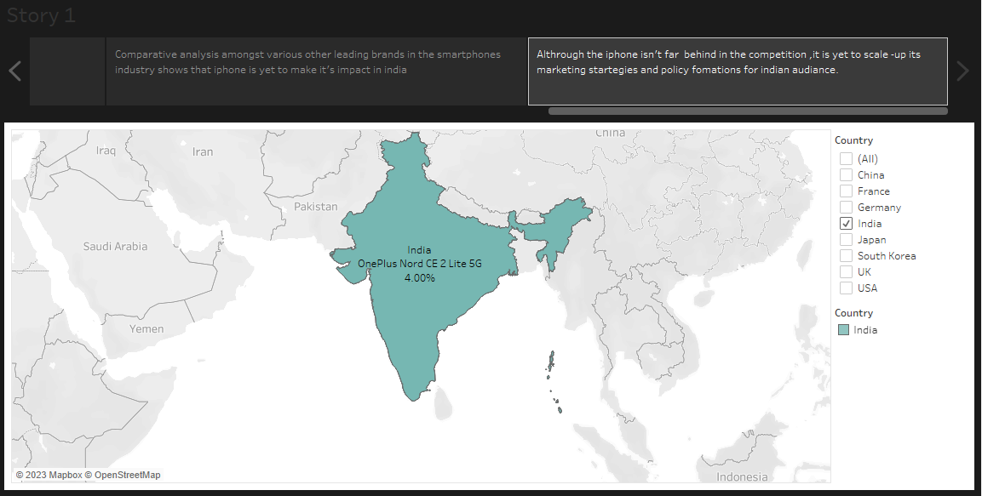

# Performance testing:

Utilization of Filters:

* In tableau, filters are a crucial feature that allows you to focus on Specific data within your visualization or analysis.
* Tableau offers various types of filters to refine and manipulate your data, providing you with more flexibility in your visualizations.

# No. of visualizations/Graphs:

* Table shows rank wish brand.
* Bargraph shows the no. of brand with model
* Table shows brand.
* Heat map shows country and brand...
* circle shows a no of mobile with a particular brand

# Publishing

Publishing Tableau Desktop to Tableau public is a process which allows to share Tableau Visualizations publicly on the internet.

# Project Demonstration & Documentation

Record explanation Video for project end to end Solution. project Documentation Step by step project development procedure.